**User Guide**

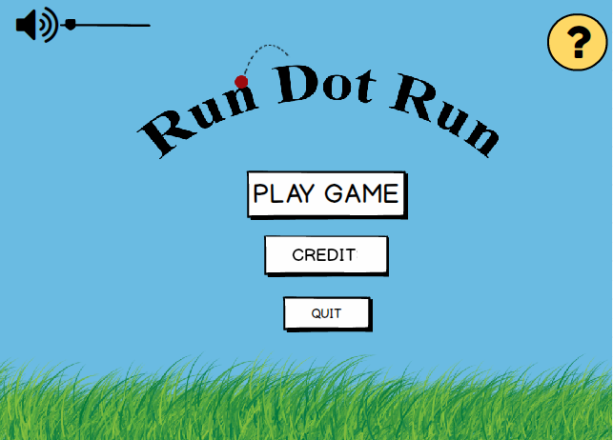

***Main Menu Screen (final version)***

The game starts with a menu screen offering a variety of options. Before playing the game, the user is able to arrange the volume of the music which will be playing on the background of the game. By clicking the question mark button at the upper right corner of the menu, user can find all necessary information about the rules of the game. Also, credit option provides the user with names of the developers of the game. If the user can exit the game with “Quit” button or display the levels screen with “Play Game” button.

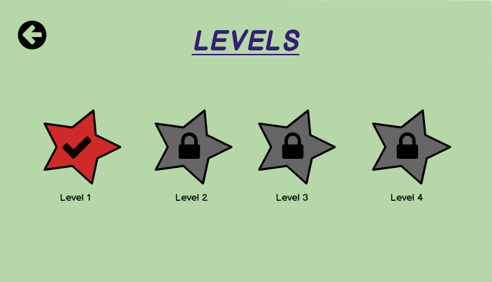

***Levels Screen***

After selecting the play game button, the levels including different types of difficulties such as spikes or erasers are displayed and the user has to select an unlocked level. After the game starts, there is a counter on the screen then, the user can check the time remaining for finishing the level.

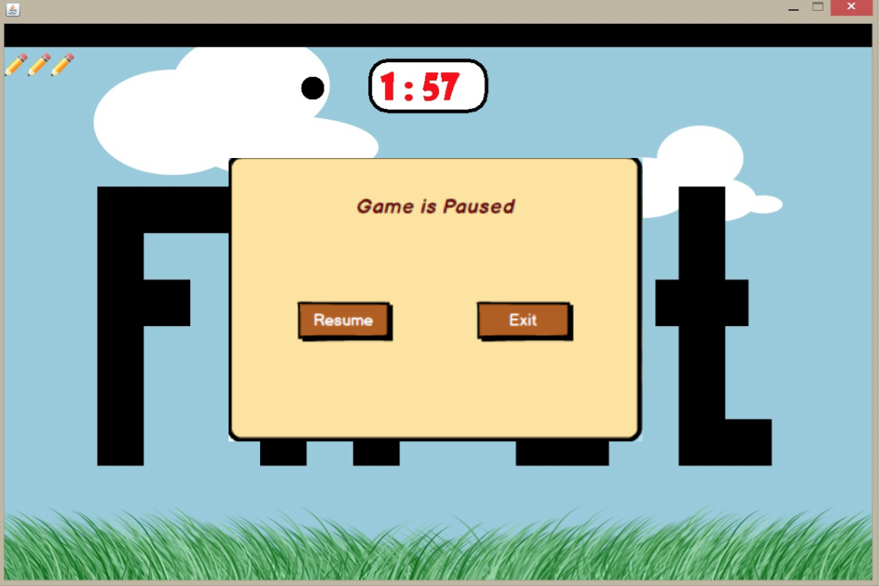

***Pause Game Screen***

By using keyboard, the user controls his/her movements during the game. The purpose of user is to reach the end of the sentence and to finish the game without falling down. At the same time, the user has to track how much time is left through checking the counter. While playing the game, the user may pause the level and return to menu by selecting exit button or continue with playing this level by selecting resume button.

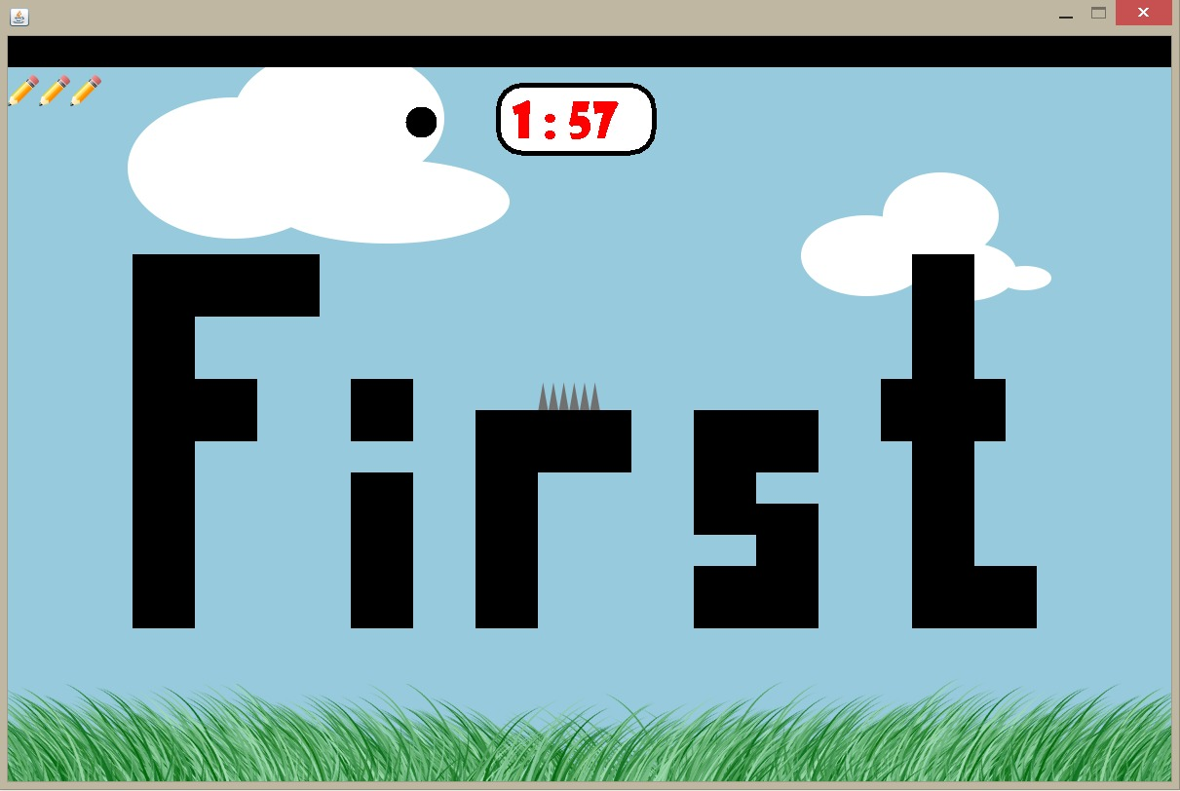

***Game Screen with Spike (Level 3)***

The user encounter diverse obstacles during the game. For instance, the user should not hit the spikes because there will be a decrease in the number of “lives” and the user will return to the beginning of the level in case of hitting spikes.

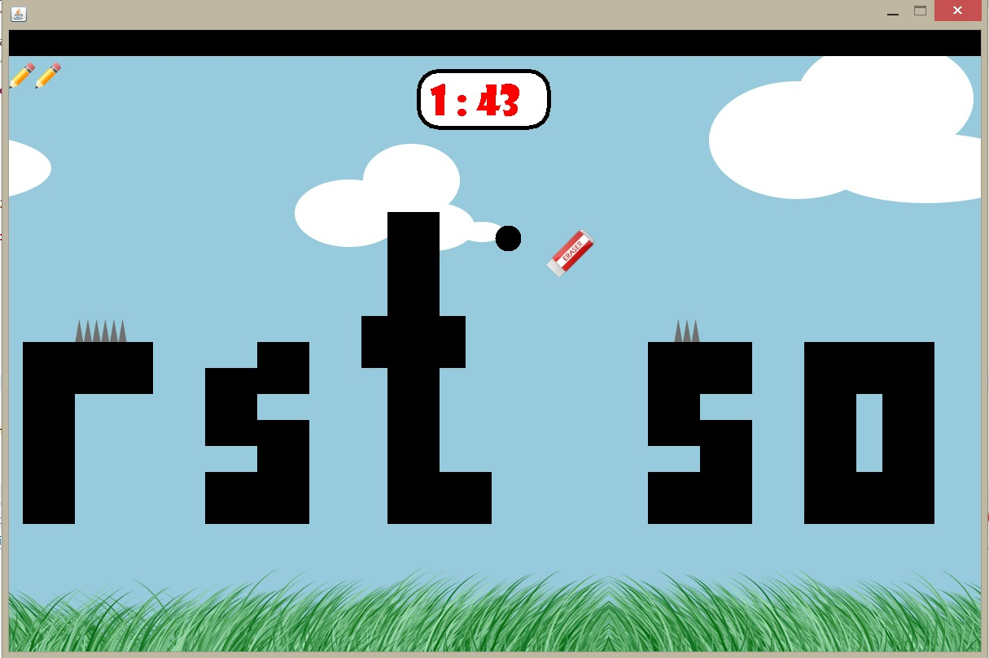

***Game Screen with Eraser (Level 3)***

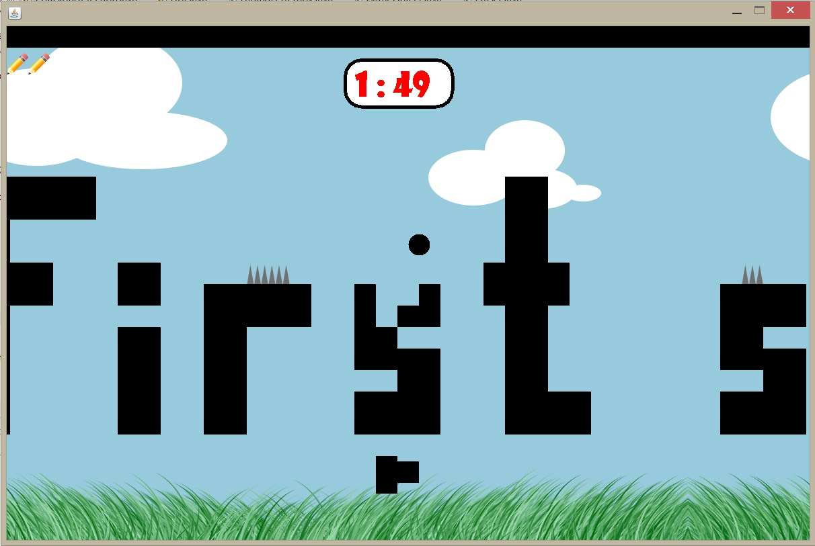Additionally, the user has to face with “erasers” which is another obstacle of the game after he/she manages to reach level 3. These eraser objects comes from the sky or the ground.

***Game Screen with Fading Letters (Level 4)***

If the user can unlock the level 4, the game starts with “fading letters” which are able to disappear in 1-2 seconds when the dot hit these letters.

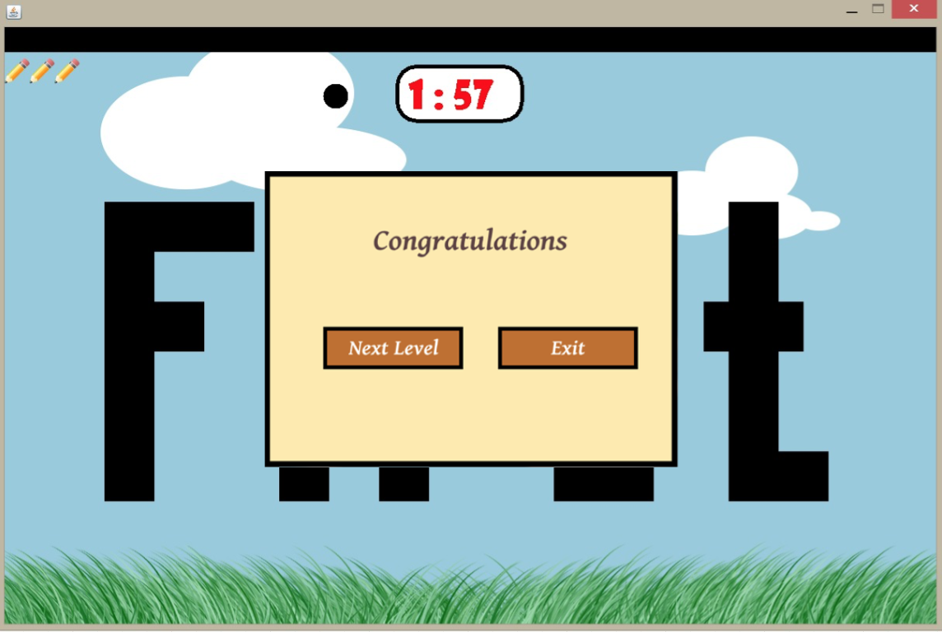

***Next Lexel Pop-Up***

If the user manages to finish any level successfully then, there will be a shown pop-up asking the user for deciding whether he/she wants to play next level or return to main menu. In case of falling down or hitting an obstacle, the user returns the beginning of the level without resetting the counter.